

Name : Sahil Gujarathi
PRN : 1262252760
DIV : 1

Foundations of Programming

Assignment No.: 14
PROBLEM STATEMENT: Write a C program to input a binary number from the user and convert it into a decimal number.

OBJECTIVE:

- To understand number system conversions.
- To learn how to convert binary numbers to decimal numbers in C.
- To practice the use of loops and arithmetic operations.
- To develop logical thinking for number system problems.

THEORY:
A binary number system uses only two digits: 0 and 1. Each digit of a binary number represents a power of 2 depending on its position. To convert a binary number into its decimal equivalent, each digit is multiplied by 2 raised to the power of its position and the results are added together. In C programming, this conversion can be implemented using loops and arithmetic operations.
PLATFORM: Linux
PROGRAM:
#include <stdio.h>
#include <math.h>

int main()
{
int binary, decimal = 0, i=0, remainder;

printf("Enter a binary number:");
scanf("%d", &binary);

while(binary != 0)
{
remainder = binary % 10;
decimal = decimal + remainder * pow(2, i);
binary = binary / 10;
i++;
}

printf("Decimal value = %d", decimal);

return 0;
}

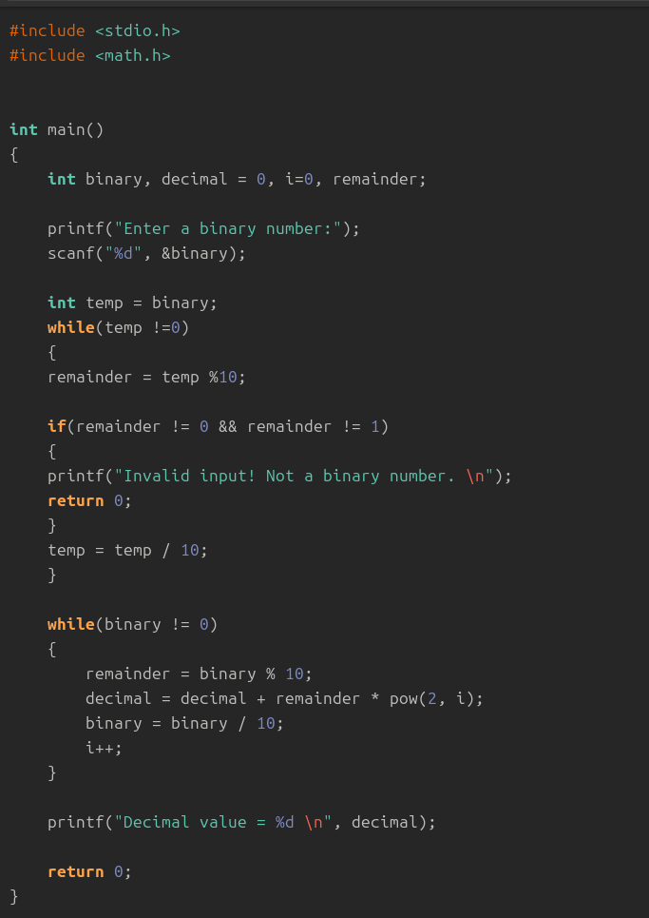

Output:

Enter a binary number:0011
Decimal value = 3

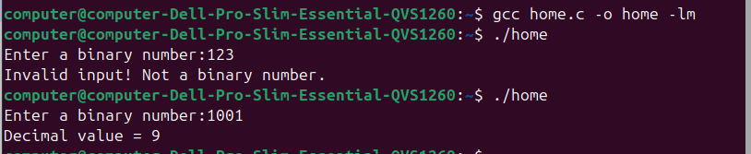

INPUT: ENTER A BINARY NUMBER: 1101

OUTPUT: DECIMAL number = 11
CONCLUSION: Thus, the C program successfully converts a binary number entered by the user into its decimal equivalent using loops and arithmetic operations.

FAQs:
- What is a binary number system?
- How is a binary number converted into a decimal number?
- What is the role of loops in binary to decimal conversion?
- What is the role of the pow() function in this program?
- What is the data type used to store binary and decimal numbers in this program?

